GUIDELINES TO LOCAL TEAMS
NEWS ALERT TEMPLATE

NEWS ALERT TITLE:
Interview – Olivier Semenoux – Head of Product Management at TCL Europe

MEDIA TARGETS: This news alert focuses on TCL's advancements in Mini-LED technology, reinforcing its position as a display technology leader. It targets generalist media, tech verticals, and business media outlets. Local markets should adapt the press release to fit their specific media needs.

TIMINGS: This news alert is relevant for immediate distribution, with coverage appearing throughout the current quarter.

USE CASE:
The primary focus is to emphasize TCL’s technological innovation in Mini-LED displays, positioning TCL as a leader in the consumer electronics industry. It highlights the advancements in Mini-LED technology, aiming to engage readers with a blend of corporate vision and product innovation.

TEMPLATE:
This news alert serves as a template designed to engage readers by presenting a cohesive brand story. It should be adapted to fit the media and market trends, aligning with local consumer interests and preferences.
CONSIDERATION:
Please avoid references to specific events or campaigns that may imply formal sponsorships or endorsements not held by TCL.

ASSETS:
All product images and portrait of Olivier Semenoux can be found here.

INTERVIEWEE: Olivier Semenoux, Head of Product Management at TCL Europe.

Introduction:  TCL, a leader in display technology, continues to push the boundaries of innovation with its latest advancements in Mini LED technology. As the market for high-performance TVs grows, TCL leverages its unique capabilities in quantum dot, and Mini LED backlighting to deliver unparalleled visual experiences. This interview with Olivier Semenoux, Head of Product Management at TCL Europe, provides insights into TCL's Mini LED technology and how TCL is pushing innovation within the electronics market. | 

1. TCL has a long history in display technology. Can you share some milestones that have shaped TCL’s journey in this field?

Olivier Semenoux: "TCL has a rich history in display technology, consistently pioneering advancements to enhance the viewing experience. From our early days as a TV manufacturer to becoming a leader in the global TV market, we have always prioritised innovation. Notable milestones include the introduction of the world's first mass-produced QD-Mini LED TV in 2019 and the OD Zero Mini LED TV launch in 2021. Each year, we have continued to push the boundaries of what's possible, culminating in our recent 2023 achievement: the world's largest 115-inch TV with over 20,000 local dimming zones. These zones allow for more precise control of brightness, meaning better contrast. This results not only in deeper blacks and brighter whites but also in more visible details in both black and white areas. Overall, Mini LED technology significantly enhances the viewing experience."

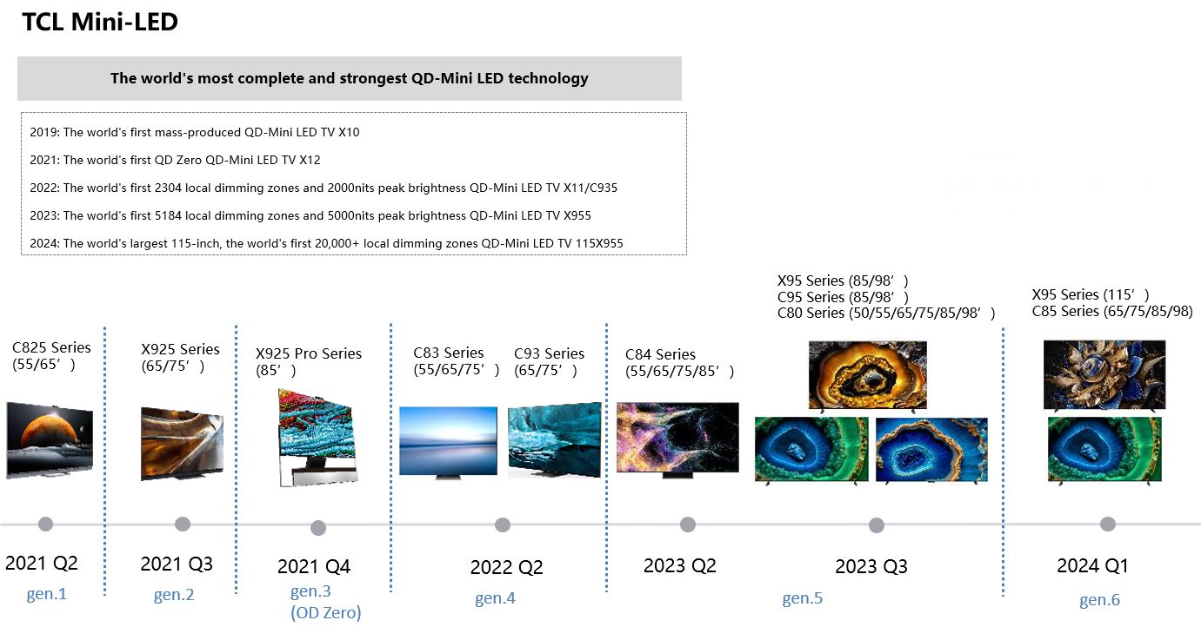

2. Why has Mini LED technology become a focal point for TCL, and how does it benefit consumers?

Olivier Semenoux: "Mini LED technology has revolutionised the display market by offering finer backlighting control, significantly improving contrast and brightness, resulting in a more immersive viewing experience with vibrant colours and deeper blacks. This aligns with our mission to provide cutting-edge, high-quality visual experiences and achieve our brand vision of 'Inspire Greatness.'

By integrating Mini LED technology, we ensure unparalleled picture quality, enhancing every viewing experience, whether it's watching a movie, playing video games, or enjoying sports. This technology allows us to create more precise and uniform lighting, translating to clearer and more dynamic images on the screen. Our commitment to innovation exemplifies our dedication to making advanced technology accessible to everyone."

3. How has TCL developed its Mini LED technology into its modern version, and what does this mean for consumers?

Olivier Semenoux: "TCL has continually advanced its Mini LED technology, now reaching the 6th generation. This latest iteration introduces significant improvements that enhance the overall viewing experience for consumers.

One significant development is the double-layer arch bridge design, which allows for more precise backlighting. This advancement leads to higher brightness and better uniformity, resulting in a clearer and more vivid picture regardless of the lighting conditions.

Additionally, our 16-bit ultra-precise light control technology provides richer colours and greater picture detail. This results in the consumers enjoying deeper blacks, brighter whites, and more dynamic images, making their viewing experience more immersive.

Furthermore, we have integrated Vertical Alignment (VA) technology, which enhances the contrast ratio compared to other display technologies. This combination ensures superior visuals, making movies, games, and sports events more enjoyable. Our continuous investment in research and development ensures that TCL remains at the forefront of display technology, delivering the best possible visual experience to our customers."

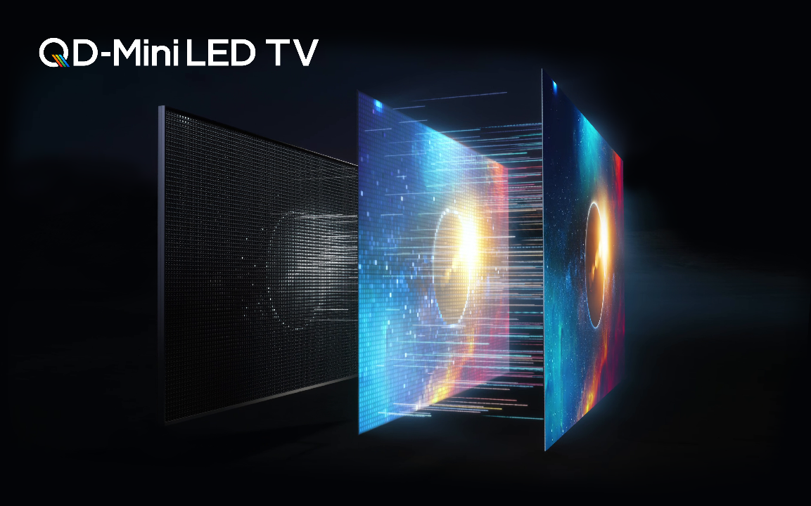

4. Reducing 'blooming' is important for picture quality. How does TCL's 6th generation Mini LED technology address this issue?

Olivier Semenoux: "Reducing 'blooming,' which is the halo effect that appears around bright objects on a dark background, is essential for enhancing picture quality. 'Blooming' can be distracting and diminishes the overall viewing experience. Our 6th generation Mini LED technology tackles this issue effectively with several advanced features.

Firstly, we use dynamic alpha technology. This technology adjusts the brightness of the LEDs more precisely, ensuring that the light is directed exactly where it's needed without spilling over into adjacent areas. This precision helps significantly reduce the halo effect around bright objects.

Secondly, our Mini LEDs are equipped with a Fresnel lens design. These lenses focus the light more accurately, improving the uniformity and clarity of the image. The Fresnel lens helps manage and direct the light more effectively, which also minimises blooming.

Additionally, the combination of these technologies ensures that our Mini LED displays offer a uniform image with much less blooming. This then produces clear and sharp visuals without distracting halos when watching a movie with high-contrast scenes or playing a video game with bright elements against dark backgrounds.

In simpler terms, consider it like adjusting a spotlight on a stage. Instead of the light spreading out and causing a glow around the spotlighted area, our technology ensures the light stays focused so only the intended area is illuminated. This results in a clearer and more enjoyable viewing experience for our customers."

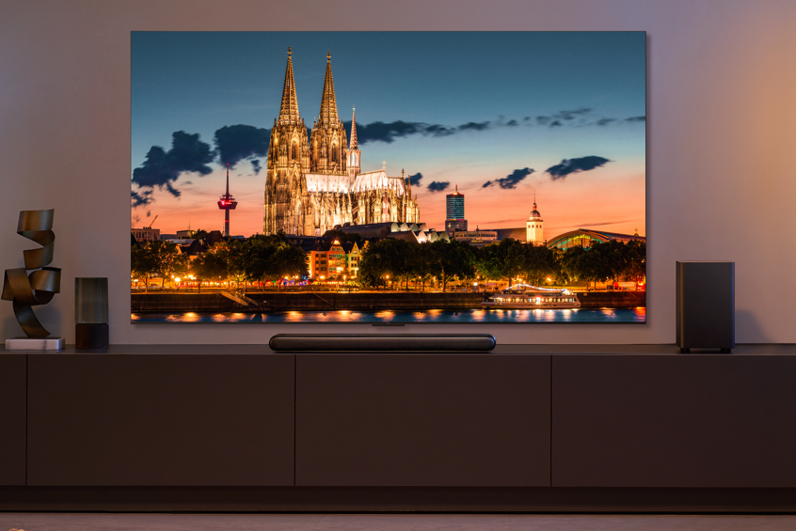
TCL C855 TV

5. How have users responded to TCL's 6th generation Mini LED technology, and what feedback have you received about their experience?

Olivier Semenoux: "The feedback from users on our 6th generation Mini LED technology has been overwhelmingly positive. Consumers have highlighted the significant improvements in their viewing experience, noting how the latest advancements have elevated their enjoyment of various content.

Users particularly appreciate the immersive experience, stating that watching movies, playing video games, and viewing sports events have become much more enjoyable. The consistency and clarity of the visuals, even in different lighting conditions, have been a standout feature for many.

Moreover, the feedback often mentions how the enhancements in our technology have made a noticeable difference in everyday use. Whether the colours' vividness or the images' overall sharpness, users feel that TCL's 6th generation Mini LED technology provides a superior viewing experience. This positive reception is a testament to our commitment to innovation and our focus on delivering high-quality products that meet and exceed consumer expectations.

Furthermore, there are numerous independent product and technology reviews available online that provide detailed feedback on TCL's 6th generation Mini LED models. For more comprehensive insights, you can search for reviews of the 'TCL C855 TV' or 'TCL C89B TV' to see what experts and users are saying about their experiences."

6. What differentiates TCL's Mini LED technology from competitors in the market?

Olivier Semenoux: “TCL stands out due to our pioneering efforts and continuous innovation in Mini LED technology. We were the first to mass-produce QD-Mini LED TVs, marking a significant industry milestone. Our commitment to pushing the boundaries of display technology has led us to consistently introduce unique and advanced features that set us apart from the competition.

A key differentiator for TCL is our approach to vertical integration. We ensure the highest quality and cost efficiency by controlling the entire production process—from manufacturing LCD panels to assembling the final products. This integrated approach allows us to implement cutting-edge technologies quickly and maintain our leadership in the industry. Our ability to oversee every step of the production process ensures that our Mini LED displays offer unmatched brightness, contrast, and uniformity, making them the most advanced on the market.

Our vertical integration also enables us to innovate more rapidly and effectively. For example, our internal R&D capabilities, such as those at our Pangu Laboratory, allow us to test and refine new technologies in-house before bringing them to market. This end-to-end control means we can ensure the feasibility and reliability of our products, consistently meeting the highest performance standards.

TCL's unique combination of pioneering innovation, advanced technology features, and a comprehensive vertical integration strategy position us as the leader in Mini LED technology. Our ability to deliver cutting-edge visual experiences while maintaining high quality and cost efficiency sets TCL apart in the competitive landscape of the consumer electronics market."

7. What future trends in display technology do you envisage, and how is TCL leading these trends across different devices?

Olivier Semenoux: "In the display technology market, we see several key trends emerging. There is a clear shift towards higher resolutions, better contrast, and innovative features like eye protection to enhance the viewing experience. TCL is at the forefront of these trends through our continuous innovation in Mini LED technology, and our exploration of future technologies such as RGB Printed OLED and Micro LED. Our focus on human-centred design ensures that we meet and exceed consumer expectations, providing superior visual experiences.

Another key trend in the display and television market is the continuous shift towards larger TV screen sizes. TCL's positions are very strong in large and very large screens: most of TCL's technology investments are dedicated to developing high-end picture quality, which is necessary and required to magnify very large screens.

Moreover, TCL's expertise in display technology extends well beyond just TVs. We leverage our advanced technologies across various devices, ensuring a cohesive and high-quality user experience across all our products. This includes everything from smartphones and tablets to larger displays like digital signage and monitors. We provide consistent and superior performance by applying our cutting-edge display technologies to various form factors, enhancing the visual experience across all our consumer electronics.

Looking ahead, we are particularly excited about our upcoming innovations, such as the revolutionary NXTPAPER display technology. This new technology promises to offer unparalleled visual comfort and performance, making it a game-changer in the market. NXTPAPER is discussed in detail by Christophe Yerolymos, who provides more insights into how this technology sets new standards in display innovation. Stay tuned for more information on how TCL continues to push the boundaries of what's possible in display technology."

# # #

Media Contact
Europe Press Relations
eupr@tcl.com

[Insert Local Contact Email Address]

# # #

About TCL Communication

TCL Communication specializes in the research, development and manufacturing of smartphones, tablets and connected devices. On a mission to deliver 5G for all, TCL Communication helps its customers ‘Inspire Greatness’ in their lives through industry leading technology and solutions. TCL Communication is a wholly owned subsidiary of TCL Electronics. For more information on TCL mobile devices, please visit: https://www.tcl.com/global/en/mobile.

About TCL Electronics

TCL Electronics (1070.HK) is one of the world's fastest-growing consumer electronics companies and one of the world's leading television and mobile device manufacturers (TCL Communication is a wholly-owned subsidiary of TCL Electronics). For more than 40 years TCL has operated its own manufacturing and R&D centers worldwide, with products sold in more than 160 countries throughout North America, Latin America, Europe, the Middle East, Africa and Asia Pacific. TCL specializes in the research, development and manufacturing of consumer electronics ranging from TVs, mobile phones, audio devices and smart home products. For more information on TCL devices, please visit: http://www.tcl.com/global/en.html.

TCL is a registered trademark of TCL Corporation. All other trademarks are the property of their respective owners.

