TCL
Press Release
Embargoed until XY, 2024, 0X:00 Paris Time
TCL Highlights Sustainable Progress and Innovations Following Earth Day Celebrations and Announces the Availability of 2023 ESG Report
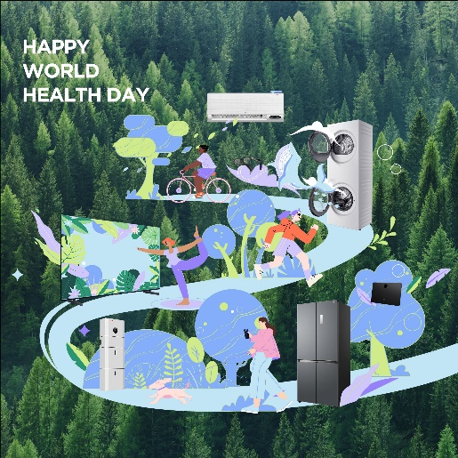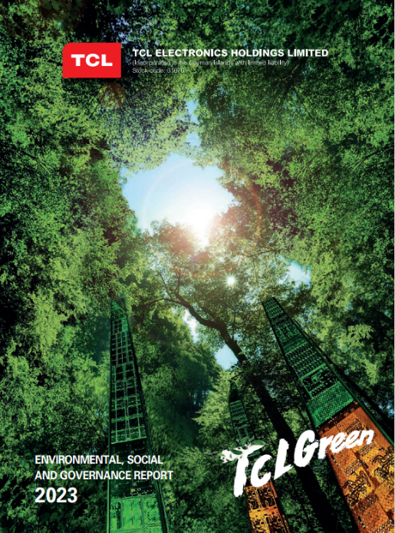
Paris – XX MAY 2024 – TCL Electronics, a leading consumer electronics brand and the world's top two TV brand, recently launched its 2023 ESG report, detailing the milestones reached on TCL's sustainability journey to date and its vision for the future.
DRIVING DOWN ENVIRONMENTAL IMPACT WITH MEASURABLE GOALS
TCL doesn’t just deliver endless entertainment and smart home appliances but is committed to go well beyond to making the earth a better place to live through responsible environmental stewardship.
Environmental targets
Taking into account the actual situations and the need for development, TCL has set more actionable targets in emission reduction, resource utilisation, and other aspects to drive sustained progress and achievements in environmental protection.
To achieve environmental targets, TCL has further refined the fundamental objectives and emission reduction targets for different departments. By clarifying management responsibilities and authorities and conducting regular assessments and performance evaluations, TCL can better track and evaluate the environmental achievements of each department, thereby ensuring the effective implementation of its environmental strategy.
Taking Climate Actions
TCL has established and followed a carbon management system and has engaged in emission and energy management efforts to minimise greenhouse gas emissions and address the challenges posed by climate change.

Promoting Circular Economy
TCL persistently strengthens waste management by optimising treatment procedures and enhancing recycling rates. TCL strives to achieve maximal resource utilisation and focus on advancing electronic waste recovery as we vigorously promote circular economy and contribute to environmental conservation and sustainable development.

TCL FOR GREEN ENERGY
TCL is deeply committed to advancing clean energy initiatives. The company contributes to the growth of solar energy solutions through significant investment in the photovoltaics sector. TCL's efforts in this area are part of a broader environmental strategy to support sustainable energy developments and ecological preservation. These initiatives align with TCL's mission to foster environmental responsibility across its global operations.

UNWAVERING DEDICATION TO GOVERNANCE AND ENVIRONMENTAL STEWARDSHIP
TCL takes responsible governance as an important corporate belief. The company strictly complies with both domestic and foreign laws and regulations, always keeps a close eye on corporate risk management, abides by business ethics, improves the governance of the Group, and promotes the Group’s continued healthy development. TCL persistently builds a sustainable supply chain, promotes the industry’s sound and stable development, and cooperates with business partners to establish a shared future for ecological development. In each local market, TCL not only meets but also strives to exceed regulatory expectations, fostering new initiatives together with clients to further CSR objectives.
External Accolades and Certifications
TCL is constantly working to actively support and nurture customers' sustainability aspirations and achievements, as evidenced by our success in receiving the prestigious EcoVadis Gold Medal Award 2024.
For over a decade, TCL’s mobile business has been rigorously evaluated by EcoVadis, a leading provider of sustainability ratings covering Environmental policies, Labour and Human Rights, Ethical Practices, and Sustainable Procurement, and received the Gold Medal in the EcoVadis 2024 annual rating, ranking among the top 5% of all companies participating in the evaluation.
Aligning with these efforts, TCL has embraced a culture of excellence, reflected in the adoption of comprehensive quality management systems and adherence to high standards that align with industry best practices for quality and sustainability. This approach demonstrates TCL’s commitment to achieving environmental excellence while maintaining operational and product quality.

Green Design
TCL Electronics always regards product quality as the lifeline of the enterprise.
The company takes green design seriously, and constantly makes breakthroughs in making greener products with lower carbon emissions.
Adhering to the concept of sustainable and low-carbon design in the whole life cycle of products, TCL formulates a green product design scheme from saving resources, reducing energy consumption, using harmless, renewable and environmentally friendly materials, and saving packaging materials.
The company fully implements extended producer responsibility in accordance with local laws and regulations, such as the EU WEEE Directive, CE Directive and Ecodesign Directive, taking accountability for the whole life cycle of our products.

#TCLGREEN: ART, INNOVATION, AND RESPONSIBILITY
#TCLGreen is a global initiative by TCL to Inspire Greatness and support efforts to create a more sustainable planet for all. This tagline applies globally to help amplify the significance of sustainability efforts to local and global communities. ‘
As one example TCL launched an art installation in collaboration with Kevin Chu, that combines physical, interactive, and metaverse art, showcasing over 1,000 upcycled circuit boards. This installation, complemented by photovoltaic technology, exemplifies TCL's dedication to creative sustainability solutions.
TCL is committed to the search for more responsible solutions by integrating the #TCLGreen concept into all aspects of its business and putting the consumers at the heart of our strategy.
Through TCL’s commitment to 'Inspiring Greatness' through its wide range of electronics, beyond innovative entertainment and smart home products, TCL is enhancing its device ecosystem with sustainable and healthy features, from NXTPAPER phones and tablets to Smart TVs and home appliances, promoting a smarter, healthier lifestyle for consumers worldwide.

LOOKING FORWARD: TCL'S ESG GOALS
TCL Electronics has never stopped and always strived for progress on the journey of sustainability. While providing healthy, accessible and green products of high quality, TCL keeps improving sustainable and low-carbon development, actively expands its clean energy business, and endeavour to drive the development of responsible supply chain system.
In addition, the company has built a diversified, fair, open and inclusive workplace and tries to deliver greater value to the society and environment. The wider ESG report also covers employment promotion, protection of employees´ rights and interests, health and safety, fair operations, consumer relations, and community participation and development in response to social concerns through actions.
As Earth Day reminds us of our shared responsibility to the planet, TCL encourages individuals and communities to join in its endeavours to create a more sustainable world. For a detailed look at TCL's sustainability initiatives and to participate in Earth Day activities, the public is invited to visit the TCL ESG report online or reach out via contact details provided.
*Source: TCL Electronics – 2023 ESG Report
# # #

Media Contact
Europe Press Relations
eupr@tcl.com
Local Press Contact
<insert local email>

# # #
TCL Green
TCL Electronics – ESG Report 2023

